Linux Kernel Module Report——2019213420

Part I : Creating Kernel Modules

Directory path: /test/simple.c

I. After editing the ***Makefile*** file and the ***simple.c*** file, enter the ***make*** command to create those files.

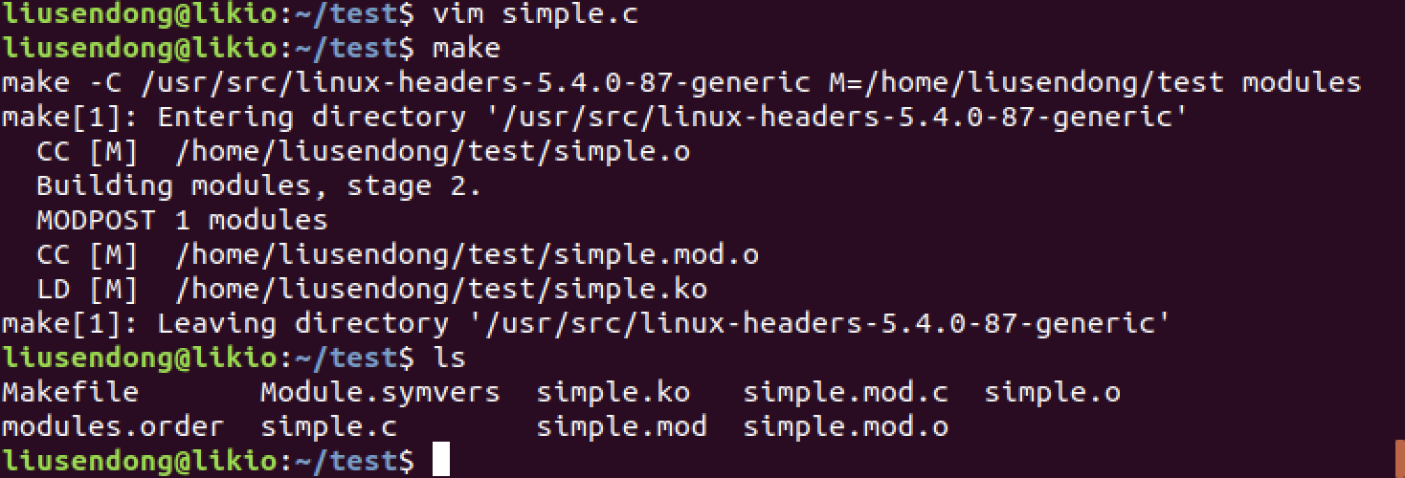

II. Enter the command **sudo insmod simple.ko to add the simple.ko** and we can see it with command **lsmod**

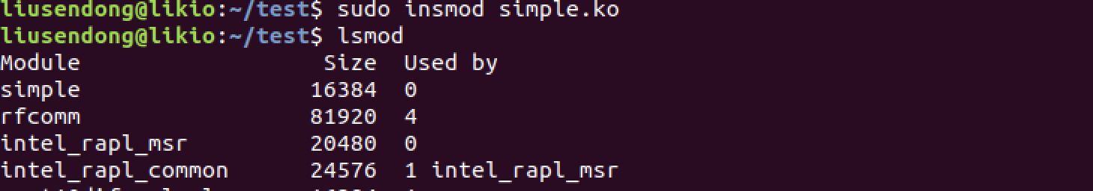

III.Enter the command **dmesg** to see the message **“Loading Module”**

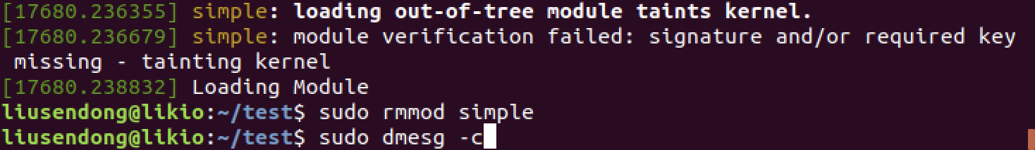

IV.Enter the command **sudo rmmod simple** to remove the module and enter **dmesg -c** to check it, we can see the message: **Removing Module**

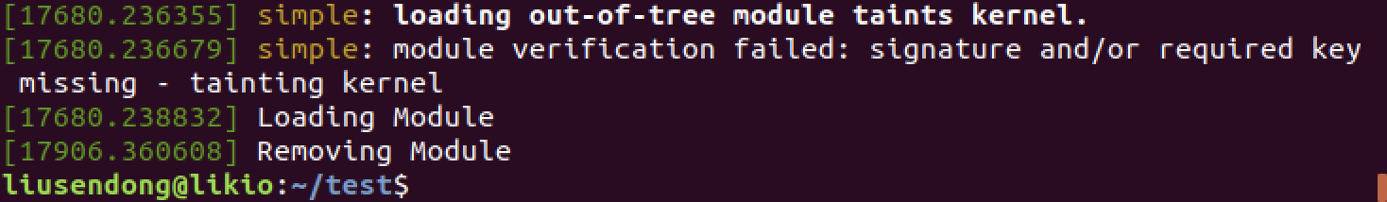

**V.** Because the kernel log buffer can fill up quickly, it often makes sense to

clear the buffer periodically. This can be accomplished as follows: **sudo dmesg -c** and we can use this command to see the Removing message

VI.Part I END.

Part II: Kernel Data Structure

Directory path: /test2/simple.c

I. After editing the ***Makefile*** file and the ***simple.c*** file, enter the ***make*** command to create proper files.

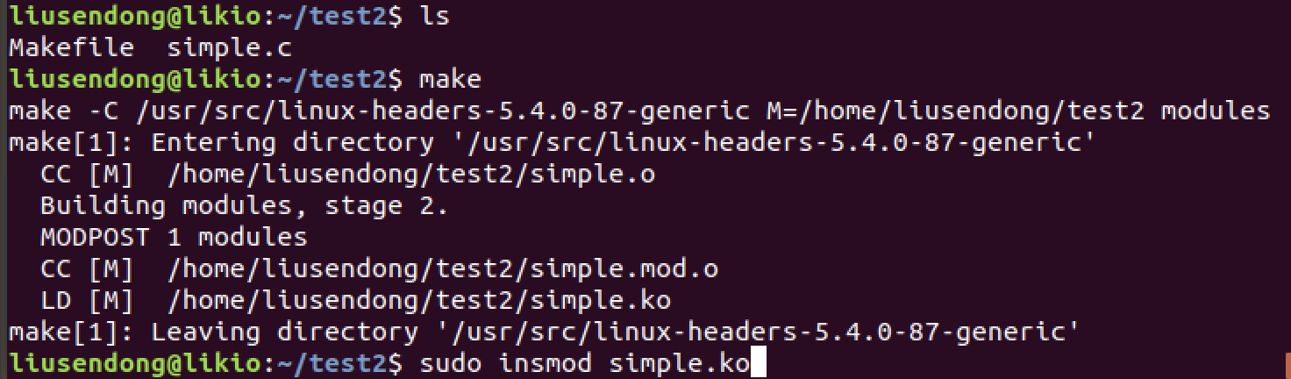

II. Enter the command **sudo insmod simple.ko to install the simple.ko** and we can see the **Loading message and 5 lines of birthday messages.**

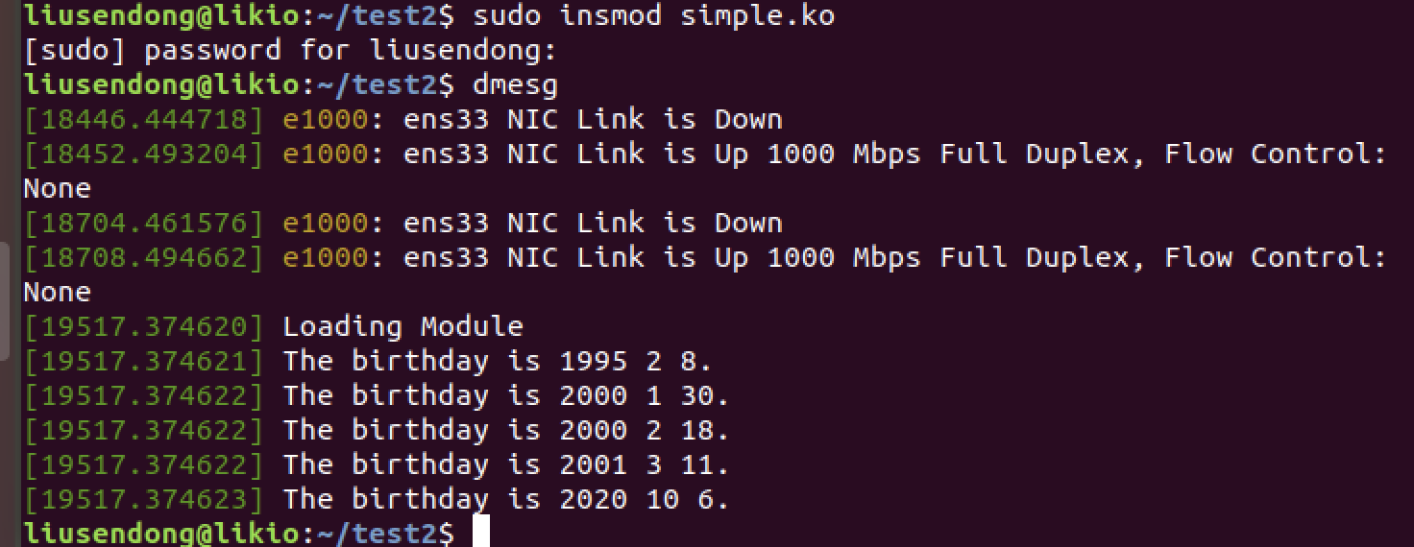

III.Enter the command **lsmod** and we can see the simple module has been added.

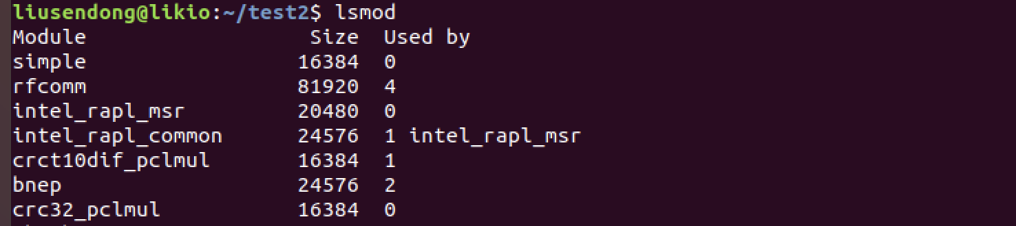

IV. Enter the command **sudo rmmod simple** to remove the module and enter **dmesg -c** to check it, we can see the message: **Removing Module**

**V.** Because the kernel log buffer can fill up quickly, it often makes sense to

clear the buffer periodically. This can be accomplished as follows: **sudo dmesg -c** and we can use this command to see the Removing message

VI. Part II END.

